15-7-26 QUERY PROCESSING FOR DATA SCIENCE SIDDARTH.P

1.Write a Pandas program to select the distinct department id from employees file.
DEPARTMENT_ID | DEPARTMENT_NAME | MANAGER_ID | LOCATION_ID
10 | Administration | 200 | 1700
20 | Marketing | 201 | 1800
30 | Purchasing | 114 | 1700
40 | Human Resources | 203 | 2400
50 | Shipping | 121 | 1500
60 | IT | 103 | 1400
70 | Public Relations | 204 | 2700
80 | Sales | 145 | 2500
90 | Executive | 100 | 1700
100 | Finance | 108 | 1700
110 | Accounting | 205 | 1700

Code:
import pandas as pd
df = pd.read_csv("departments.csv")
print(df['DEPARTMENT_ID'].drop_duplicates())

Output:
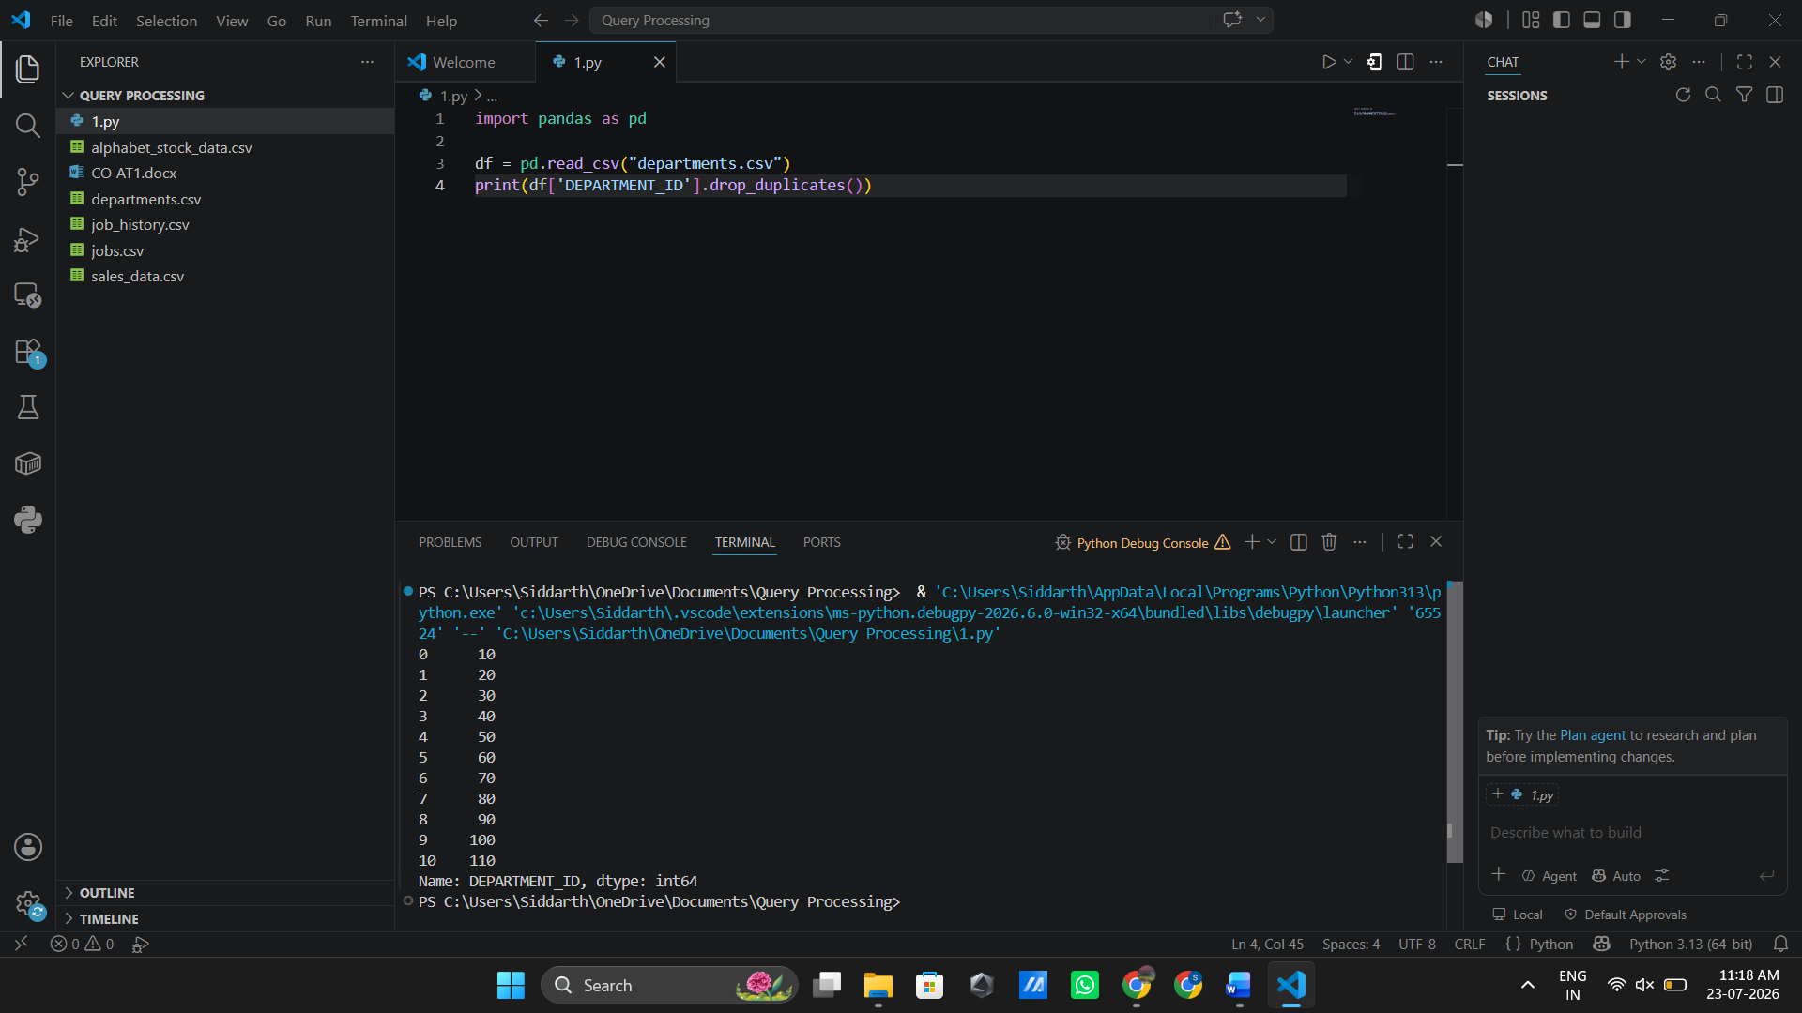
2.Write a Pandas program to display the IDs of employees who have done two or more

EMPLOYEE_ID | START_DATE | END_DATE | JOB_ID | DEPARTMENT_ID
102 | 2001-01-13 | 2006-07-24 | IT_PROG | 60
101 | 1997-09-21 | 2001-10-27 | AC_ACCOUNT | 110
101 | 2001-10-28 | 2005-03-15 | AC_MGR | 110
176 | 2006-03-24 | 2006-12-31 | SA_REP | 80
176 | 2007-01-01 | 2007-12-31 | SA_MAN | 80
200 | 1995-09-17 | 2001-06-17 | AD_ASST | 90
200 | 2002-07-01 | 2006-12-31 | AC_ACCOUNT | 90

Code:
import pandas as pd

df = pd.read_csv("job_history.csv")
result = df.groupby('EMPLOYEE_ID').filter(lambda x: len(x) >= 2)
print(result['EMPLOYEE_ID'].drop_duplicates())

Output:
